CALCULATOR BUTTON | PURPOSE | PRACTICE PROBLEMS
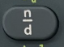 | FRACTION
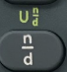 | MIXED NUMBER
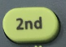 | “SHIFT”
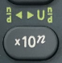 | SIMPLIFY  (change to mixed #/improper fraction)
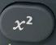 | NUMBER SQUARED
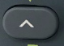 | RAISED TO A POWER OF…
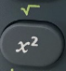 | SQUARE ROOT
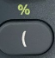 | PERCENT  (used with multiplication)
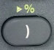 | CHANGE TO PERCENT
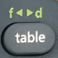 | CHANGE TO FRACTION/DECIMAL
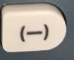 | NEGATIVE NUMBER
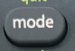 | MODE BUTTON
 | ARROW BUTTON
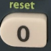 | “CLEAR ALL”
 | TOGGLE BUTTON

