SOLVING PERCENT PROBLEMS - PART 1
20% of 40 change 20% to a decimal - 0.20 then multiply 0.20 x 40 = 8

But there are lots of different kinds of percent problems in GED questions.
For example: 12 is what percent of 48?
5 is 10% of what number?

We can use ________________________________ to solve all types of percent questions.

A proportion uses equivalent fractions and a process called __________________ _________________ _______ _______________.
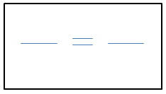

“PERCENT” means ----> PER 100 So, we always put the 100 on the bottom of the fraction and the % or X above it. We use an X to represent a number we do not know. “What percent” or “what number” should be written as X in our proportion.

- What is 5% of 120?
- What is 75% of 680?
- 40% of what number is 16?
- 30 is what percent of 120?
- 70 is 12.5% of what number?
- A local electricians’ union has 540 members. If 65% of the members attended the last meeting, how many of the members went to the meeting?

- For selling his townhouse, Martin had to pay the real estate agent a commission of 8%. The townhouse sold for $115,000. How much was the agent’s commission?

